A

Report On

**“Online Inventory Management System”**

**Under the subject**

**‘Advanced Java Programming [22517]’**

**Submitted by**

|  |  |  |
| --- | --- | --- |
| **Sr. No** | **Enrollment No** | **Name of the student** |
| 1 | 1700100271 | Miss. Shinde Mohini Anandrao |
| 2 | 1700100371 | Mr. Kolekar Jayash Prakash |
| 3 | 1700100370 | Mr. Patil Pratik Kumar |
| 4 | 1800100002 | Mr. Kare Abhilash Sudam |

**Under the guidance of**

Mr. Emekar S. P.

&

Miss. Joshi D. S.

Department of Computer Engineering

Government Polytechnic, Karad

**1.0 Rationale**

Inventory or stock is the goods and materials that a business holds for the ultimate goal of resale. It is a discipline primarily about specifying the shape and placement of stocked goods. It is required at different locations within a facility or within many locations of a supply network to precede the regular and planned course of production and stock of materials. The scope of Inventory Management concerns the balance replenishment lead time, carrying costs of inventory, asset management, inventory forecasting, inventory valuation, inventory visibility, physical inventory, available physical space, quality management, returns and defective goods, and demand forecasting. Balancing these competing requirements leads to optimal inventory levels, which is a ongoing process as the business needs shift and react to the wider environment.

Our project consists of Inventory Management System. The system is web based project which will be created using Java Servlet Programming (JSP), Java Programming, Java Database Connectivity (JDBC), JavaScript, HTML, CSS (Cascading Style Sheets),etc.

**2.0 Aim of the project**

1. To analyze working of Online Inventory Management System.
2. To address importance of proper Inventory Management.
3. To study concepts of Advanced Java Programming.
4. To create a web-based system for Inventory Management.

We have achieved all the aims which were decided at the start of the project. We have completed the project with achieving all the aims at the completion.

**3.0 Course Outcomes Achieved**

1. Develop programs using GUI framework (AWT and Swing).
2. Handle events of AWT and swing components.
3. Develop programs to handle events in Java Programming.
4. Develop programs using database.
5. Develop programs using servlets.

**4.0 Literature Review**

|  |  |  |
| --- | --- | --- |
| **Author (Publication)** | **Abstract** | **Conclusion** |
| Dr. Tariq Sheakh (ResearchGate) | This paper consisted the information about Inventory Management System | We used this paper to understand the process of Inventory Management System |
| Arjun Guha (Brown University) | This paper explains the increasing popularity of JavaScript in development of web applications | We used this paper to understand the importance of JavaScript in Web Application development |
| Md. Zeeshan Ahmad (IJCSMC) | This paper explains the process for development of slider in web pages | We used this paper to develop sliders in our project. |
| Muzafer H. Saracevic (Technics Technologies Education Management) | This research paper consisted of the details about JSP language | We used this a reference to implement JSP language in our project |
| Weiming Wu (Advances in Intelligent and Soft Computing) | This journal consisted of the process of the MYSQL database connectivity from JSP page | We used this information to connect database from the JSP page |
| Xiaolong Pan (ResearchGate) | This paper explains how to make the web application responsive | We used this paper to make our webapplicaton responsive |

**Table 1- Literature Review**

**5.0 Actual procedure followed**

Actual procedure followed during the project is mentioned in the table below with the planned start date and completed finish date.

|  |  |  |  |  |
| --- | --- | --- | --- | --- |
| **Sr.no** | **Details of activity** | **Planned**  **Start date** | **Planned**  **Finish date** | **Name of responsible Team members** |
| 1. | Collecting information about Inventory Management System | 15/07/2019 | 27/07/2019 | 1.Patil Pratik  2.Kolekar Jayash |
| 2. | Collecting the information about concepts of JSP, Java, CSS, JavaScript, HTML,etc., | 28/07/2019 | 05/08/2019 | 1.Shinde Mohini  2.Kare Abhilash |
| 3. | Collecting the information together and analyzing the structure of the code | 06/08/2019 | 15/08/2019 | 1.Shinde Mohini  2.Kare Abhilash |
| 4. | Developing the rough design of the system | 16/08/2019 | 22/08/2019 | 1.Kolekar Jayash  2.Patil Pratik |
| 5. | Actual Coding | 23/08/2019 | 31/08/2019 | 1.Patil Pratik  2.Kare Abhilash  3.Shinde Mohini  4.Kolekar Jayash |
| 6. | Testing | 1/09/2019 | 11/09/2019 | 1.Kare Abhilash  2.Patil Pratik  3.Shinde Mohini  4.Kolekar Jayash |
| 7. | Preparing final project report | 12/09/2019 | 22/09/2019 | 1.Shinde Mohini  2.Kolekar Jayash  3.Patil Pratik  4.Kare Abhilash |

**Table 2- Actual procedure followed**

**JSP Pages and their description**

|  |  |
| --- | --- |
| **Page Name** | **Description** |
| 1. **addproduct** | Adds the new product in the database |
| 1. **computerrecord** | Displays details of computer products |
| 1. **createaccount** | Stores the registration details in the database |
| 1. **customer** | Displays the order details of customer from database |
| 1. **deleteproduct** | Deletes product from the database |
| 1. **laptoprecord** | Displays details of laptop products |
| 1. **login** | Validates login from the database |
| 1. **mobilerecord** | Displays details of mobile products |
| 1. **printerrecord** | Displays details of printer products |
| 1. **receipt** | Adds the order data in the database and prints the receipt |
| 1. **soundrecord** | Displays details of sound products |
| 1. **tvrecord** | Displays details of tv products |

**Table 3- JSP Pages**

**Database Tables**

|  |  |
| --- | --- |
| **Table Name** | **Description** |
| 1. **computer** | Stores details of the computer products |
| 1. **customer** | Stores the details of ordered products by customer |
| 1. **laptop** | Stores details of the laptop products |
| 1. **mobile** | Stores details of the mobile products |
| 1. **printer** | Stores details of the printer products |
| 1. **sound** | Stores details of the sound products |
| 1. **tv** | Stores details of the tv products |
| 1. **users** | Stores details of the registered customers |

**Table 2- JSP Pages**

**HTML Pages and their description**

|  |  |
| --- | --- |
| **Page Name** | **Description** |
| 1. **about** | Contact information and some trusted brands |
| 1. **co1** | Details of First Computer |
| 1. **co2** | Details of Second Computer |
| 1. **co3** | Details of Third Computer |
| 1. **co4** | Details of Fourth Computer |
| 1. **co5** | Details of Fifth Computer |
| 1. **co6** | Details of Sixth Computer |
| 1. **computerslider** | Computer products page |
| 1. **createaccount** | Registration page |
| 1. **home** | Home page |
| 1. **index** | Home page for user who has signed in |
| 1. **laptopslider** | Laptopproducts page |
| 1. **login** | Login page |
| 1. **lp1** | Details of First Laptop |
| 1. **lp2** | Details of SecondLaptop |
| 1. **lp3** | Details of ThirdLaptop |
| 1. **lp4** | Details of FourthLaptop |
| 1. **lp5** | Details of FifthLaptop |
| 1. **lp6** | Details of SixthLaptop |
| 1. **mobileslider** | Mobileproducts page |
| 1. **mp1** | Details of First Mobile |
| 1. **mp2** | Details of Second Mobile |
| 1. **mp3** | Details of Third Mobile |
| 1. **mp4** | Details of Fourth Mobile |
| 1. **mp5** | Details of Fifth Mobile |
| 1. **order** | Order page for customer |
| 1. **pr1** | Details of First Printer |
| 1. **pr2** | Details of Second Printer |
| 1. **pr4** | Details of Third Printer |
| 1. **pr5** | Details of Fourth Printer |
| 1. **pr6** | Details of Fifth Printer |
| 1. **pr7** | Details of Sixth Printer |
| 1. **printerslider** | Printerproducts page |
| 1. **so1** | Details of First Sound |
| 1. **so2** | Details of Second Sound |
| 1. **so3** | Details of Third Sound |
| 1. **so4** | Details of Fourth Sound |
| 1. **so6** | Details of Fifth Sound |
| 1. **so7** | Details of Sixth Sound |
| 1. **soundslider** | Soundproducts page |
| 1. **tv1** | Details of First TV |
| 1. **tv2** | Details of Second TV |
| 1. **tv3** | Details of Third TV |
| 1. **tv4** | Details of Fourth TV |
| 1. **tv5** | Details of Fifth TV |
| 1. **tv6** | Details of Sixth TV |
| 1. **tvslider** | TVproducts page |

**Table 3- HTML Pages**

**6.0 Actual Resources Required**

The resources used during the completion of project are mentioned in the below

|  |  |  |  |  |
| --- | --- | --- | --- | --- |
| **Sr.no** | **Name of resources material** | **Specifications** | **Quantity** | **Remarks** |
| 1. | YouTube | MP4-file format, 640 x 360 pixels | 1 |  |
| 2. | Microsoft Word | 2010 version | 1 |  |
| 3. | Eclipse | As Required | 1 |  |
| 4. | Laptop | Dell, RAM 8 GB, Harddisk 1 TB, i3 processor | 1 |  |
| 5. | MYSQL | Version 5.2.8 | 1 |  |
| 6. | Apache Tomcat | Version 9.0 | 1 |  |

**7.0 Outputs of the Micro-project**

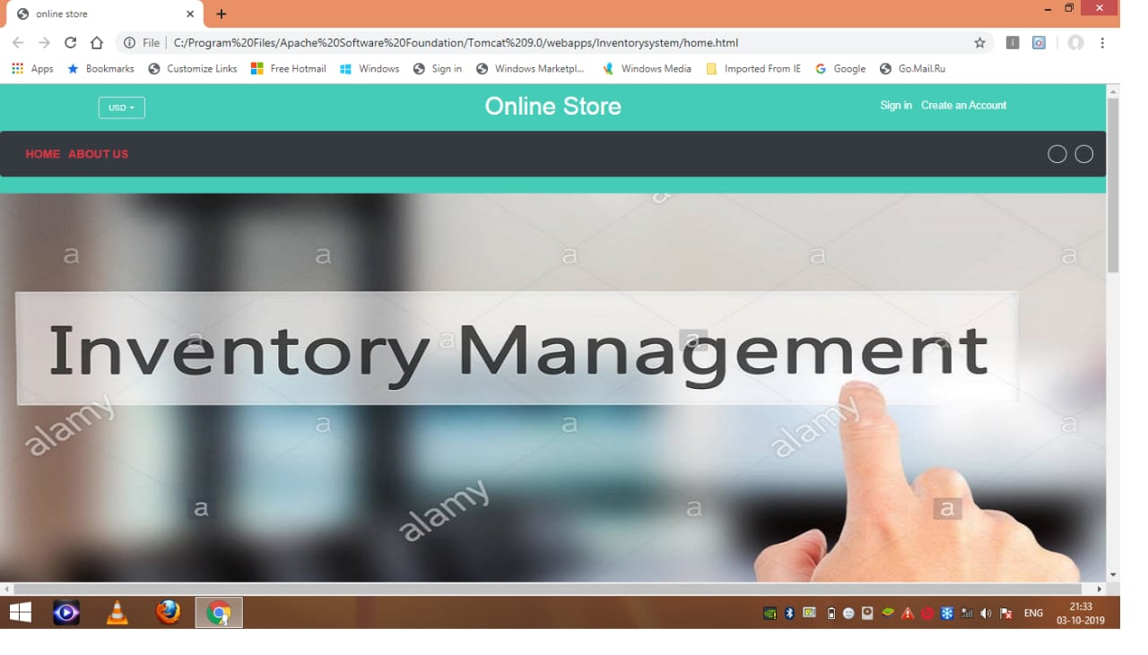

**Fig 1-Home Page**

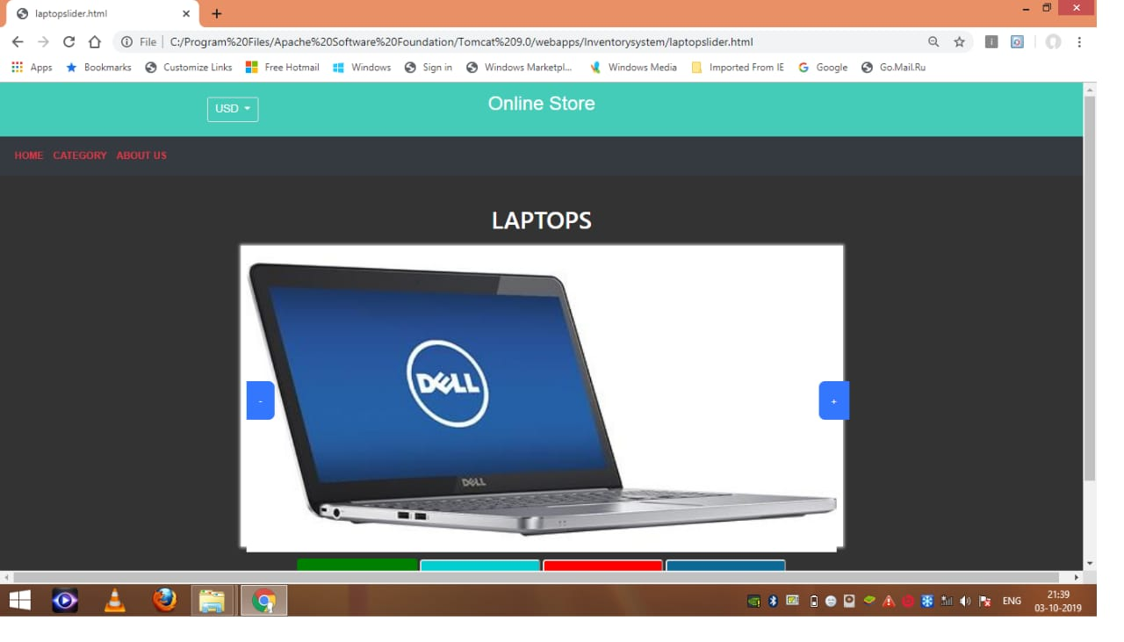

**Fig 2-Laptops Page**

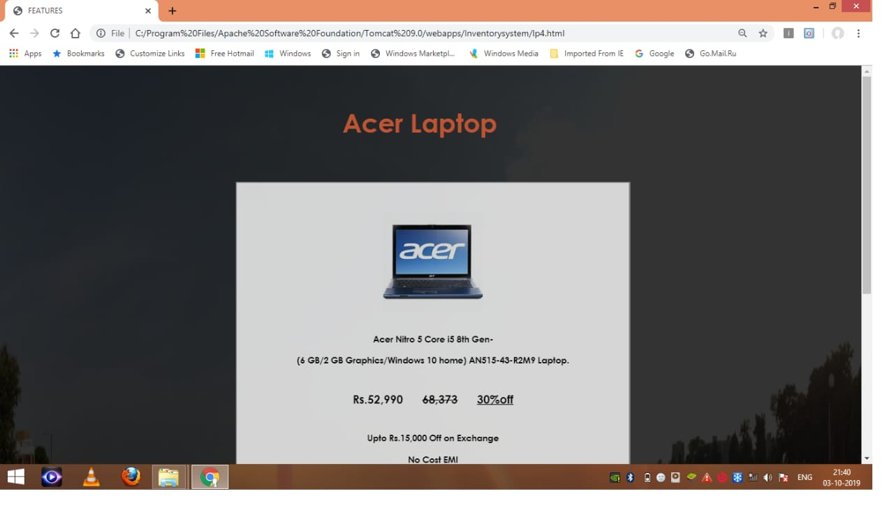

**Fig 3-Acer Laptop Details Page**

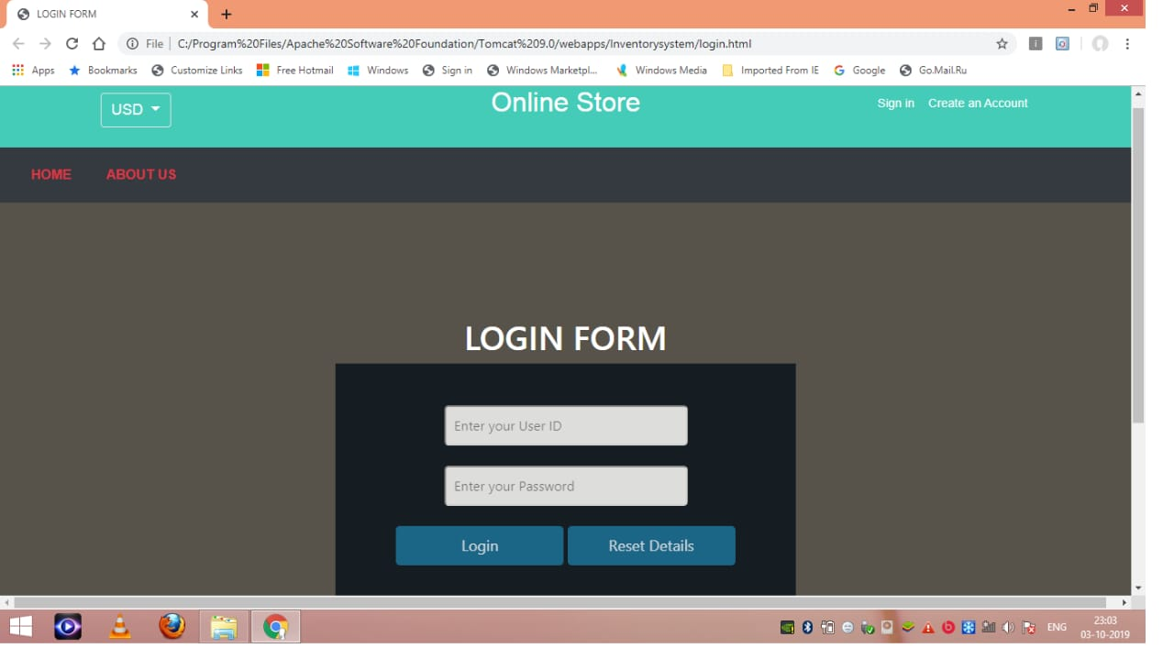

**Fig 4-Login Page**

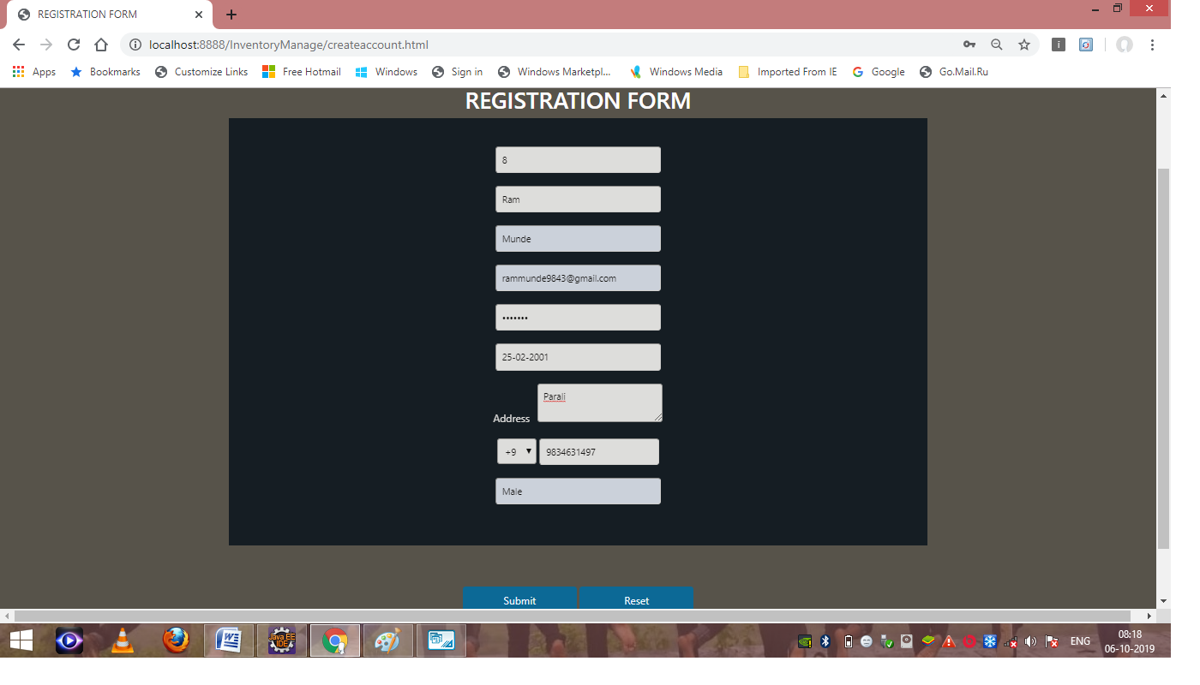

**Fig 5- Data entered by the user in the Registration form**

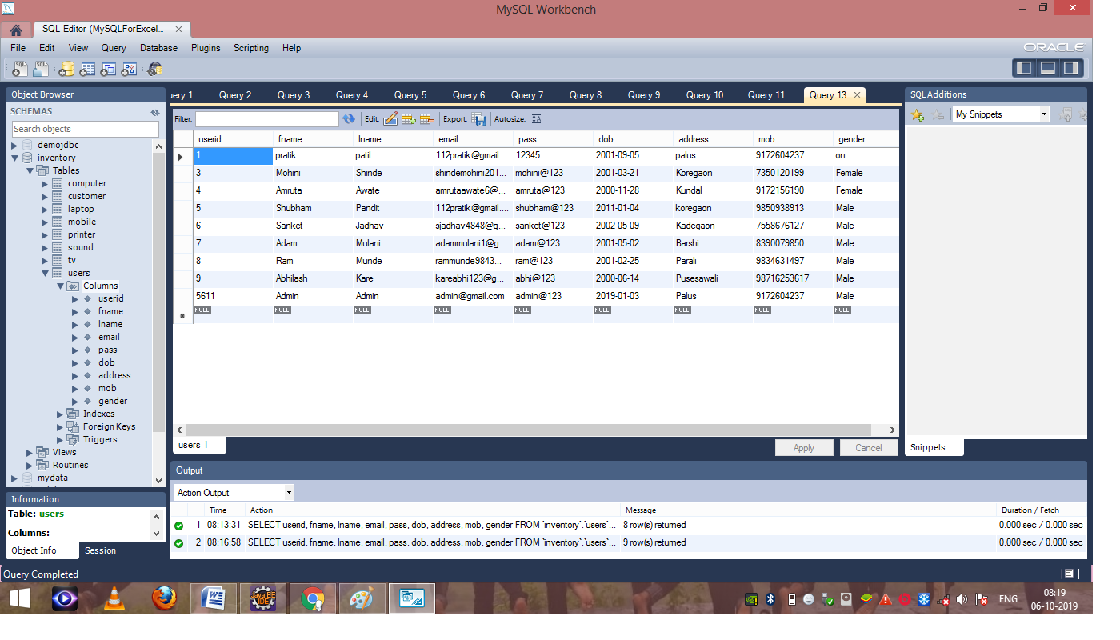

**Fig 6- Data of user stored in database which was entered in registration form**

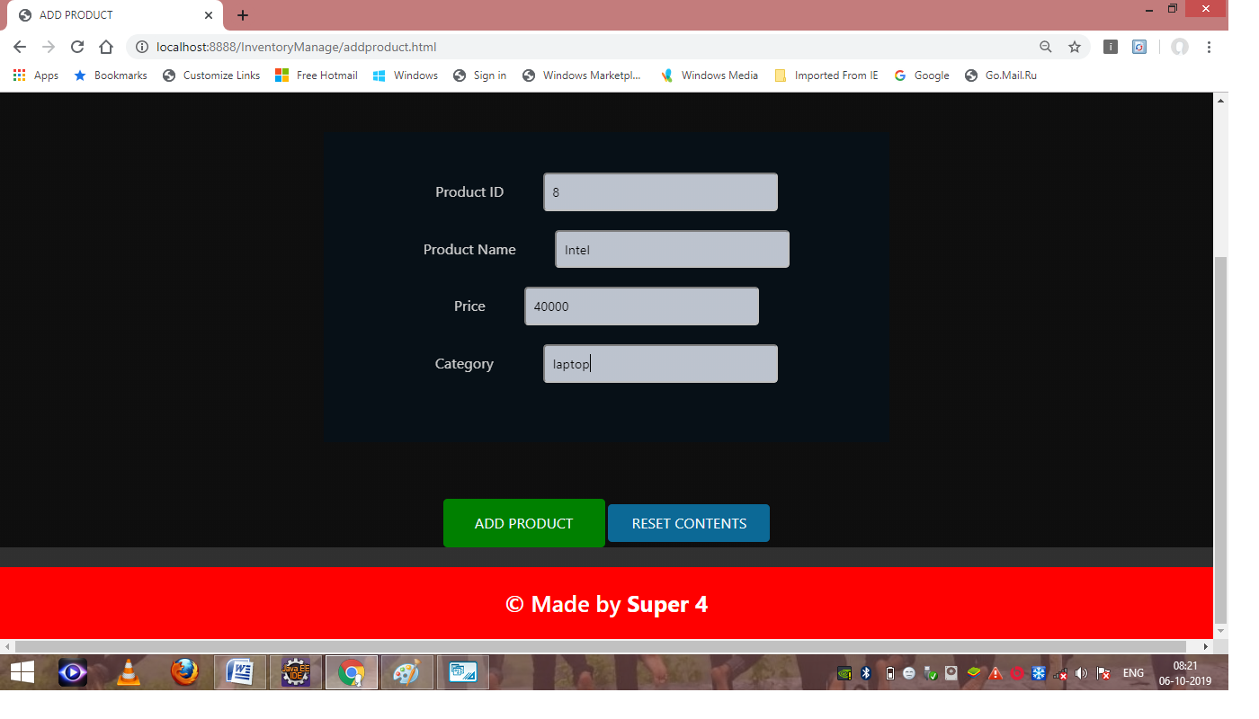**Fig 7- Details of new product to be inserted**

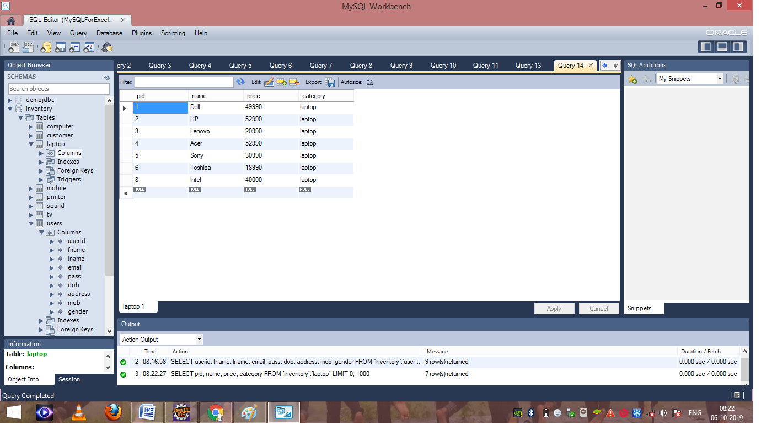

**Fig 8- Details of the new product being saved successfully**

**8.0 Skill Developed/ learning out of this Micro-Project**

We learnt,

1. Developing an Online Inventory Management System.
2. Importance of Database connectivity.
3. Importance of Java Servlet Programming.
4. Importance of JavaScript.
5. Efficient communication skills.
6. Working as a team member.
7. Developing leadership qualities.

**9.0 Applications of the Project**

1. This project can be used in the implementation of Online Inventory Management System.
2. The project can be also used to understand Java Servlet Programming.
3. The project can be used in purchasing electronics devices.

**Subject Teacher**

**Mr. Emekar S. P.**

**Miss. Joshi D. S.**